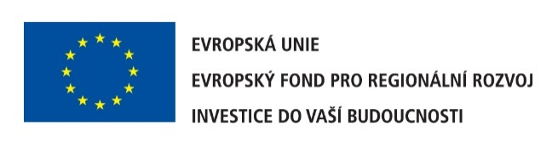

Investment into new technologies

We are pleased to inform you that Seaborne Plastics has received the grant from Operational Programme Enterprise and Innovation. The grand we used for expanding production capacities and new technology for thermoforming. We have the financial grand in the total amount 7 030 138 CZK, we have invested into the CNC Power Turbo FC 3200, the thermoforming machine Geiss DU1000 x 800 x 400, the 3D laser scanner Steinbichler T Scan CS and the I-TEMP TT60 18KW.
From a long-term perspective, new technologies help us to increase the quality of our products and provide our customers with the excellent standard services.

